**Problem Solving**

**Object Oriented Programming**

**Name: Hari Krishna Shah**

**VIT ID: 21BCS0167**

**Link:** [**https://drive.google.com/drive/folders/12TXT5bExID5DFUjCnfyjfIuH3a66H73K?usp=sharing**](https://drive.google.com/drive/folders/12TXT5bExID5DFUjCnfyjfIuH3a66H73K?usp=sharing)

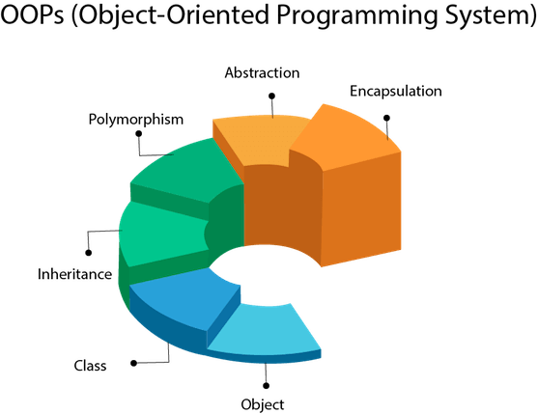

**Question: Prepare the Bill for the customers in an Online Sports Shop.**

**Answer:**

**Aim: To Prepare a billing system for online sports shop.**

Concepts used:

1. Classes and objects to create and store the inventory
2. Classes and objects to create and store the cart items.
3. Friend class and friend function to allow class cart to access private data members of class inventory.
4. Dynamic Memory Allocation to create array of dynamic size
5. Dynamic constructors to initialize the data members of pointer data type.
6. Destructors to deallocate the dynamically allocated memory to the pointer data type data members of the object and destroy the object
7. Passing entire array of class objects to a function
8. Forward Declaration of object.
9. And many more.

Below is the fully functional application for billing of sports shop.

Users can select the items that they want to buy. After selecting the item, the application puts them into cart. User can keep on adding items in the cart till they want.

The inventory items are saved using the objects of user defined data type i.e class of inventory. Similarly, the cart items are saved using the objects of the class cart.

#include <iostream>

#include <malloc.h>

#include <string.h>

**using** **namespace** std**;**

*/*Forward declaration of class cart so that class inventory can know that class cart exists somewhere*

*in the program and the class cart is its friend.*/*

**class** cart**;**

**class** inventory**{**

*// making class cart as a friend class of class inventory so as to access the private data members of inventory class.*

**friend** **class** cart**;**

**private:**

**char** product_name**[**100**];**

**float** price**;**

**int** reference_no**;**

**public:**

**void** get_details**(char[],** **float,** **int);**

**void** display_inventory**();**

**int** check_reference**(int** cart_ref**);**

**};**

**int** inventory**::**check_reference**(int** cart_ref**){**

**if(**reference_no **==** cart_ref**){**

**return** 1**;**

**}**

**else{**

**return** 0**;**

**}**

**}**

**class** cart**{**

**private:**

*// creating int array to store reference numbers of the added items in the cart.*

**int** **\***cart_items**;**

**float** total_price**;**

**public:**

*//Creating a constructor to dynamically allocate memory for the cart_items;*

cart**(){**

*// Default size of cart_items is enough to store 10 int numbers i.e 40 bytes total.*

cart_items **=** **(int** **\*)** **(**malloc**(**10 **\*** **sizeof(int)));**

total_price **=** 0**;**

**}**

**~**cart**(){**

free**(**cart_items**);**

**}**

**void** add_item**(int,** **int);**

**void** display_cart**(int,** **class** inventory p**[]);**

**void** check_out**();**

**};**

**void** inventory**::**get_details**(char** name**[**100**],** **float** p_price**,** **int** ref_no**){**

strcpy**(**product_name**,** name**);**

price **=** p_price**;**

reference_no **=** ref_no**;**

**}**

**void** inventory**::**display_inventory**(){**

cout**<<"Product Name: "<<**product_name**<<**endl**;**

cout**<<"Price: "<<**price**<<**endl**;**

cout**<<"Reference Number: "<<**reference_no**;**

**}**

**void** cart**::**add_item**(int** cart_ref**,** **int** cart_count**){**

cart_items**[**cart_count **+** 1**]** **=** cart_ref**;**

*// Dynamically allocating memory for cart_item of the class cart*

cart_items **=** **(int** **\*)** **(**realloc**(**cart_items**,** **(**cart_count **+** 10**)** **\*** **sizeof(int)));**

cout**<<"Item added to your cart successfully."<<**endl**;**

**}**

**void** cart**::**display_cart**(int** cart_count**,** **class** inventory p**[]){**

**float** temp_price **=** 0**;**

cout**<<"Below is/are your cart-items."<<**endl**;**

**for(int** i **=** 0**;** i**<=**cart_count**;** i**++){**

cout**<<"Item number "<<** i**+**1**<<**endl**;**

**for(int** j **=** 0**;** j**<**5**;** j**++){**

**if(**p**[**j**].**reference_no **==** cart_items**[**i**]){**

p**[**j**].**display_inventory**();**

temp_price **+=** p**[**j**].**price**;**

cout**<<**endl**<<**endl**;**

**}**

**}**

**}**

total_price **=** temp_price**;**

cout**<<"Total Price is RS "<<**total_price**<<**endl**;**

**}**

**void** cart**::**check_out**(){**

free**(**cart_items**);**

cout**<<"Thank you for shopping with us. !"<<**endl**;**

total_price **=** 0**;**

**}**

**int** main**(){**

**class** inventory p**[**5**];**

**class** cart cart_obj**;**

**int** cart_ref**,** cart_count **=** **-**1**;** *//cart_count is -1 signified the cart is emoty.*

p**[**0**].**get_details**("Atheletic_Shoes",** 2500**,** 1**);**

p**[**1**].**get_details**("Skipping_Rope",** 500**,** 2**);**

p**[**2**].**get_details**("Cricket_Bat",** 1500**,** 3**);**

p**[**3**].**get_details**("Football",** 500**,** 4**);**

p**[**4**].**get_details**("Baseball_Bat",** 1800**,** 5**);**

**int** option **=** 0**;**

**while(**option **!=** **-**1**){**

cout**<<"\t\t\t***Welcome to the Shah Sports Store***\n"<<**endl**;**

cout**<<"The following products are available with us currently."<<**endl**;**

**for(int** i **=** 0**;** i**<**5**;** i**++){**

cout**<<"Product Number - "<<**i**+**1**<<**endl**;**

p**[**i**].**display_inventory**();**

cout**<<**endl**<<**endl**;**

**}**

cout**<<"Please select an option from the menu below:\n \**

**Enter 1 to add items to your cart\n \**

**Enter 2 to view your cart\n \**

**Enter 3 to checkout\n \**

**Enter -1 to exit the store"<<**endl**;**

cout**<<"Enter your option here: ";**

cin**>>**option**;**

**switch(**option**){**

**case** **-**1**:{**

cout**<<"Thank You for shopping with us."<<**endl**;**

**break;**

**}**

**case** 1**:{**

**int** flag **=** 0**;**

cout**<<"Enter the reference number of the product that you want to add in your cart: ";**

cin**>>**cart_ref**;**

**for(int** i **=** 0**;** i**<**5**;** i**++){**

flag **=** p**[**i**].**check_reference**(**cart_ref**);**

**if(**flag **==** 1**){**

**break;**

**}**

**}**

**if(**flag **==** 0**){**

cout**<<"Invalid Reference number. Try adding the item again."<<**endl**;**

**}**

**else{**

cart_obj**.**add_item**(**cart_ref**,** cart_count**);**

cart_count **+=** 1**;**

**}**

**break;**

**}**

**case** 2**:{**

**if(**cart_count **==** **-**1**){**

cout**<<"The cart is empty. Please add some items in your cart first."<<**endl**;**

**}**

**else{**

cart_obj**.**display_cart**(**cart_count**,** p**);**

**}**

**break;**

**}**

**case** 3**:{**

**if(**cart_count **==** **-**1**){**

cout**<<"The cart is empty. Please add some items in your cart first."<<**endl**;**

**}**

**else{**

cart_obj**.**display_cart**(**cart_count**,** p**);**

cart_obj**.**check_out**();**

cart_count **=** **-**1**;**

**}**

**break;**

**}**

**}**

**}**

**return** 0**;**

**}**

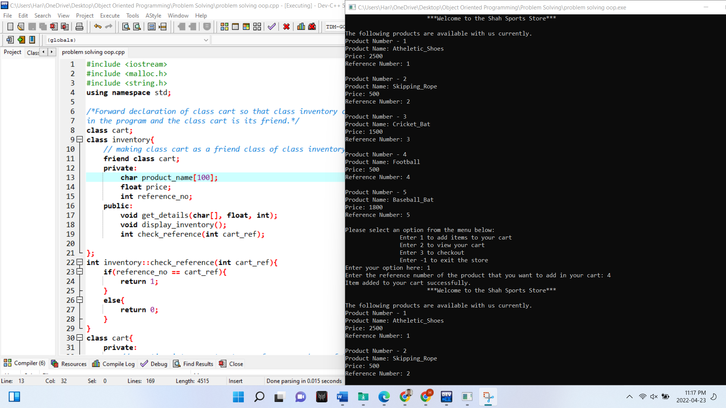

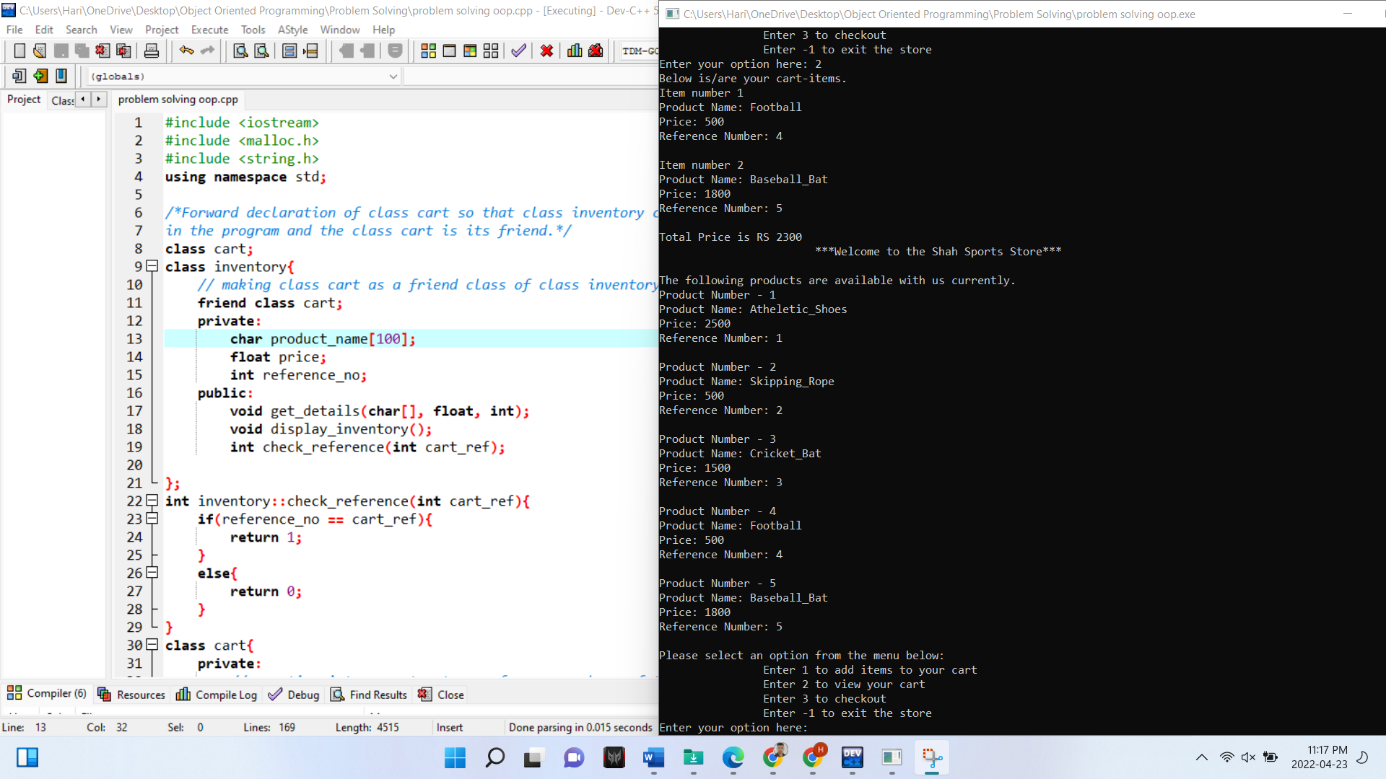

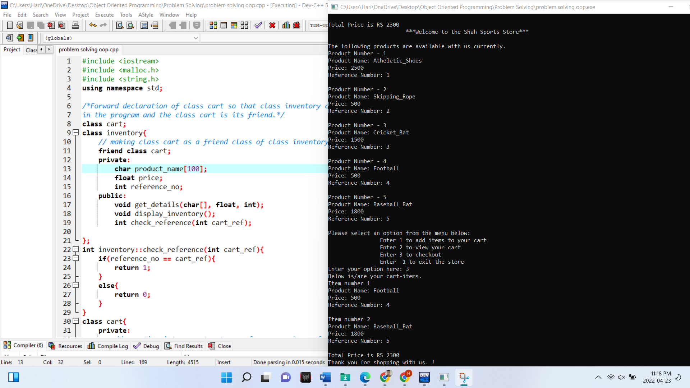

**Hand Written Explanation**

